The most popular start and end stations appear in Manhattan and Brooklyn, which is most likely due to its dense population and vast number of visitors compared to other New York City boroughs.

<https://public.tableau.com/app/profile/nathan.payne4079/viz/StationDashboard_16816896296590/Dashboard1?publish=yes>

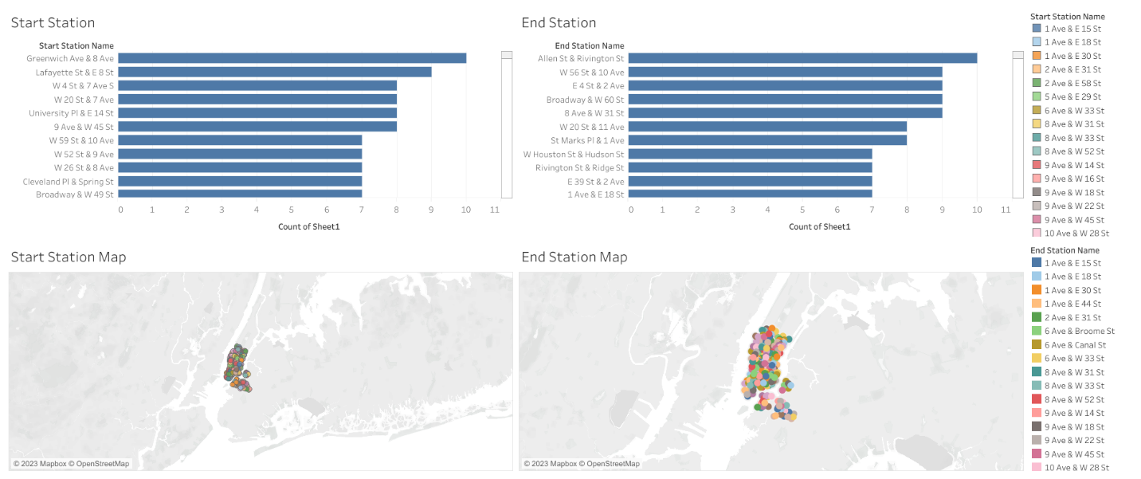

The Tableau chart provided is a dashboard that presents overall and gender-related data for a New York City bike share rides. The dashboard is divided into three parts, with each part providing information on various aspects overall trip duration, average gender trip duration, and overall gender rides.

Over a six month period, July-December, average bike ride duration dropped during the fall and winter months compared to the summer. This is true for overall rides of female riders. This trend can most likely be attributed to lower temperatures in New York City during those months.

<https://public.tableau.com/app/profile/nathan.payne4079/viz/GenderDashboard_16817570886810/Dashboard2?publish=yes>

